**Assignment 3**

1.Declare two variables of type int, and assign values to them. Add the two variables together and print the result.

[**https://codeshare.io/lonxYD**](https://codeshare.io/lonxYD)

2.Declare two variables of type double, and assign values to them. Multiply the two variables together and print the result.

[**https://codeshare.io/3Abqkz**](https://codeshare.io/3Abqkz)

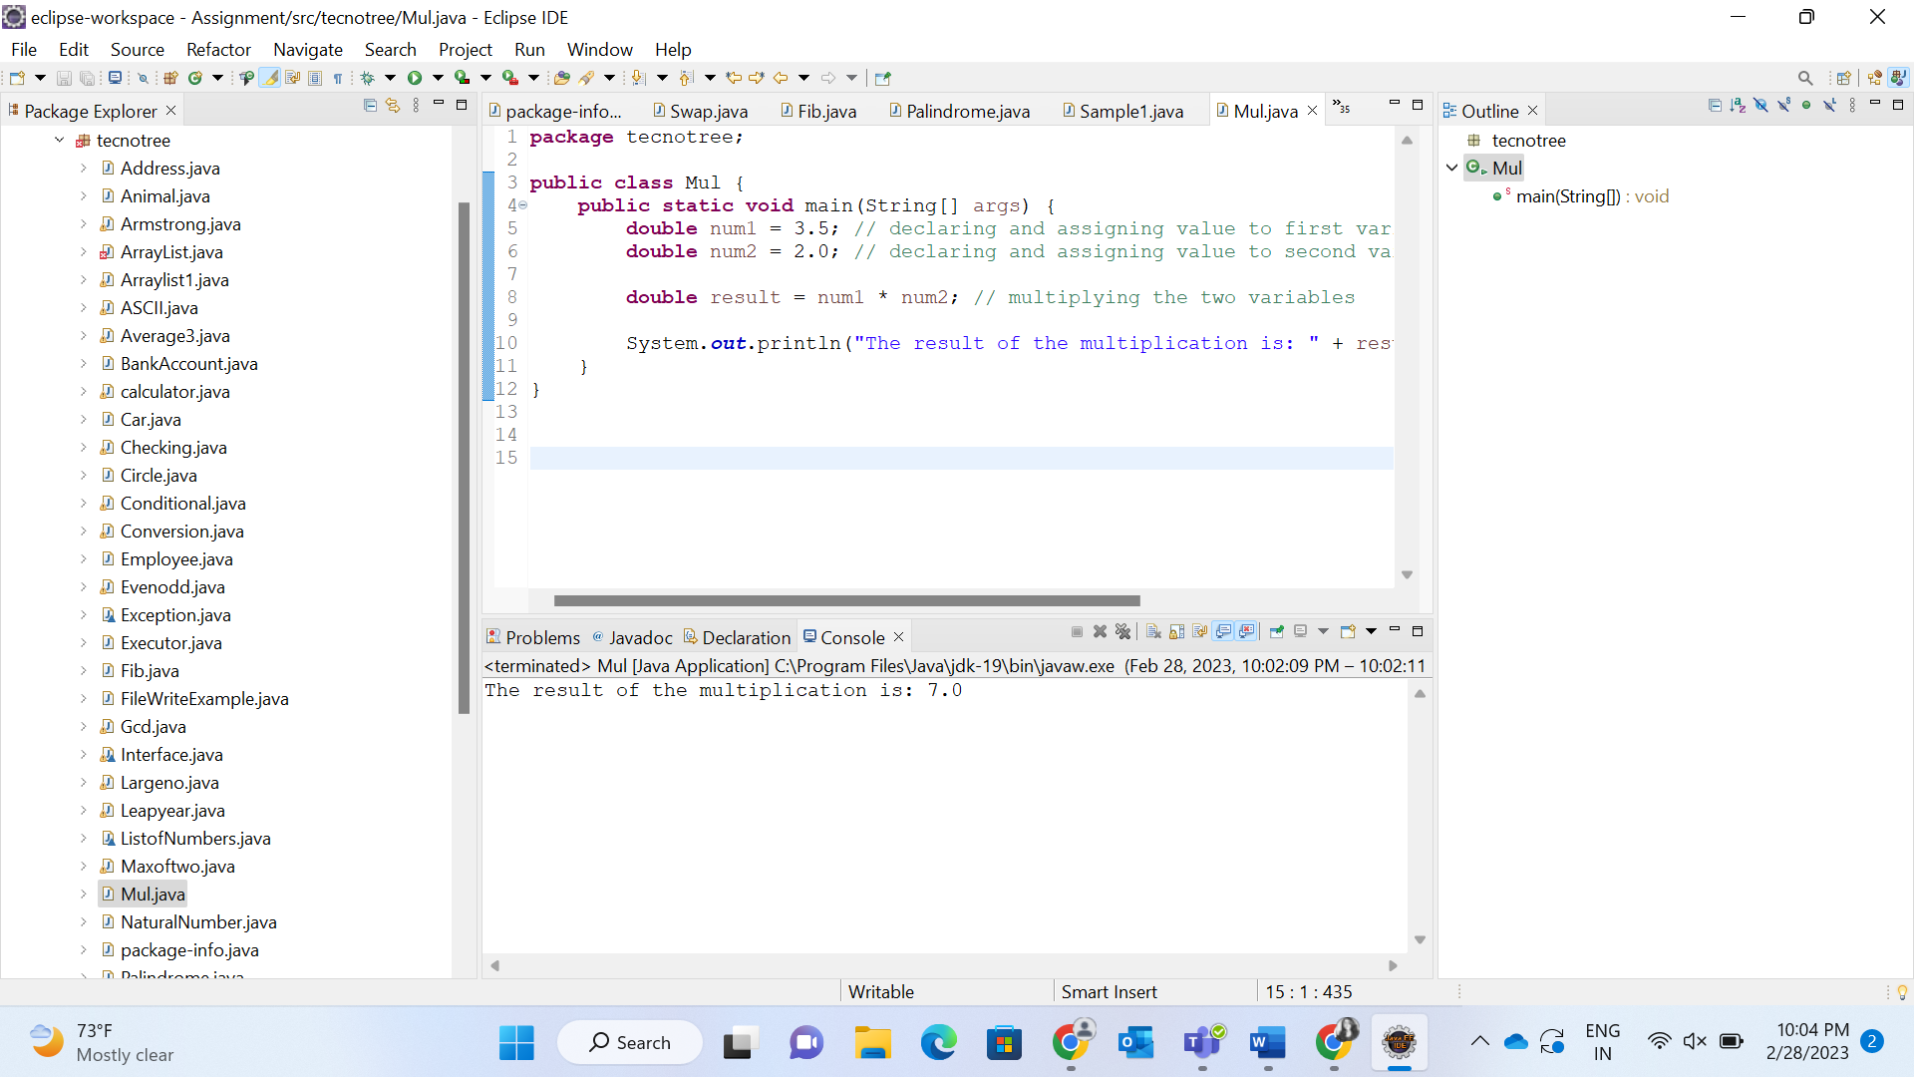

3.Declare two variables of type boolean, and assign values to them. Print out the value of the logical AND operator applied to the two variables.

<https://codeshare.io/ZJEkAX>

4.Declare a variable of type String, and assign it a value. Use the String class method length() to print out the length of the string.

[**https://codeshare.io/Ad1Wdw**](https://codeshare.io/Ad1Wdw)

5.Declare a variable of type String, and assign it a value. Use the String class method toUpperCase() to print out the string in all uppercase letters.

<https://codeshare.io/j0dYAB>

6.Declare a variable of type String, and assign it a value. Use the String class method substring() to print out a portion of the string.

<https://codeshare.io/xv4n8P>

7.Declare a variable of type String, and assign it a value. Use the String class method indexOf() to find the index of a specific character in the string.

<https://codeshare.io/JbMJpq>

8.Declare a variable of type char, and assign it a value. Convert the character to its ASCII code and print out the result.

<https://codeshare.io/0gveqQ>

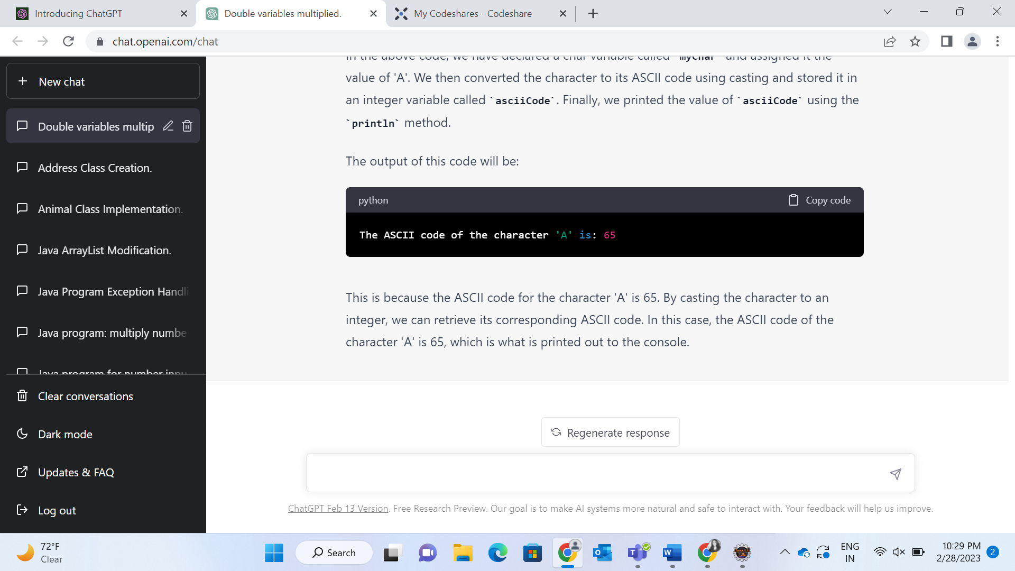

9.Declare a variable of type int, and assign it a value. Convert the integer to a String and print out the result.

<https://codeshare.io/6pkoAk>

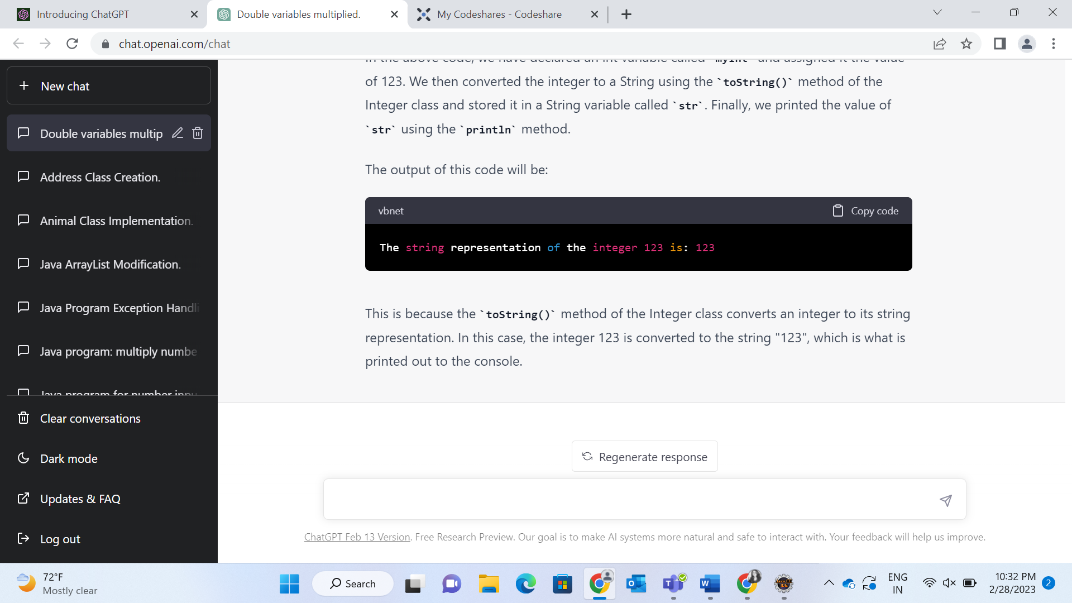

10.Declare a variable of type double, and assign it a value. Convert the double to an int and print out the result.

<https://codeshare.io/DZEprY>

